

Capstone Project Phase B
ThrivePath - Overcoming FTT Through Innovation
PROJECT CODE:
25-1-D-17
Supervisor:
Dr. Natali Levi-Soskin

Authors:
Kfir Sharoni, ID: 206013559
KfirSharoni1@gmail.com
Avishay Halifa, ID: 209404425
AvishayHalifa@gmail.com‬
GitHub Repository

Table of Contents
1. Abstract 3
2. Introduction 4
3. Development Process and Technological Implementation 5
3.1 Activity diagram 5
3.2 Development Process 6
4. Use and maintenance 7
4.1 Package Diagram 7
4.2 User Guide 8
4.3 Maintenance Guide 16
5 Testing 29
5.1 User Authentication Testing: 29
5.2 Patient Management Process Testing: 30
5.3 Treatment Plan Dashboard Testing: 31
5.4 Patient Growth Tracking Process Testing: 32
6. Results and Conclusions 34
6.1 Project Objectives and Achievements: 34
6.2 Considerations in Our Decision-Making Process: 35

1. Abstract
This project presents ThrivePath, a digital platform designed to improve the management of Failure to Thrive (FTT) in children. FTT is a common pediatric condition that affects physical growth and may have long-term health consequences if not properly addressed. Current digital tools in this field are limited, either focusing solely on diagnosis or offering generic nutritional advice without providing personalized, comprehensive treatment plans. ThrivePath addresses this gap by offering a fully integrated solution that generates personalized treatment recommendations based on basic physical measurements-age, weight, height, and gender.
The platform provides caregivers with clear, customized daily plans covering nutrition, physical activity, sleep, and hydration. It is designed for ease of use by non-medical users, offering a simple interface to enter child data, generate treatment protocols, and track progress over time. One of the key features of the system is its Growth Monitoring functionality, which allows caregivers to record and review their child's height and weight history through interactive growth charts. The platform automatically updates treatment recommendations as new data is entered, ensuring continuous, adaptive care.
From a technical perspective, ThrivePath combines a modern web architecture- using React, Next.js (powered by Node.js), and MongoDB-with AI-generated meal plans powered by the OpenAI API. The system also includes a robust backend to manage patient profiles and treatment records securely.
The project demonstrates how technology can simplify pediatric care by transforming complex medical guidelines into actionable, easy-to-follow treatment plans. By focusing on usability, adaptability, and ongoing monitoring, ThrivePath provides a meaningful, long-term tool for caregivers and healthcare professionals alike, improving the management of FTT in daily life.

2. Introduction
Failure to Thrive (FTT) represents a significant challenge in pediatric healthcare, affecting a child's physical growth and potentially impairing cognitive and emotional development. Clinically, FTT is diagnosed when a child’s weight-for-age measurement falls below the 3rd percentile on multiple occasions, or when there is a notable drop across growth percentiles. The causes of FTT are typically classified as either organic-stemming from medical conditions such as chronic illnesses or genetic disorders-or non-organic, often related to psychosocial or environmental factors like neglect, poor feeding practices, or insufficient caregiver knowledge. Regardless of the underlying cause, FTT requires early and consistent intervention to prevent long-term health complications.
Current methods for managing FTT involve multidisciplinary care, including pediatricians, nutritionists, and social workers. Treatments typically combine medical assessments, dietary interventions, and psychological support. However, despite the availability of various tools and services, existing solutions remain fragmented. Digital platforms such as FTTell assist in diagnosing the condition but stop short of offering treatment plans, while others focus solely on plotting growth curves or providing generalized nutritional advice. These tools do not deliver comprehensive, personalized care tailored to each child’s unique physical profile, leaving caregivers without the guidance they need for effective home-based intervention.
To address this gap, we developed ThrivePath, a digital platform aimed at improving the management of FTT through personalized, accessible, and integrated care. Unlike existing tools, ThrivePath does not rely on diagnostic reports or behavioral observations. Instead, it uses straightforward physical data-height, weight, age, and gender-to calculate the child’s caloric needs and construct a complete treatment plan. This plan includes personalized meal suggestions, hydration recommendations, physical activity guidelines, and sleep duration targets, all adapted to the child’s age and physical condition.
The platform is designed to be intuitive and easy to use, even for parents without medical or technological backgrounds. It allows caregivers to add children, input measurements, and receive an immediate, evidence-based protocol tailored to the specific needs of each child. The user can track growth over time, update physical data, and download the full treatment plan for ongoing use or consultation with healthcare professionals.

3. Development Process and Technological Implementation

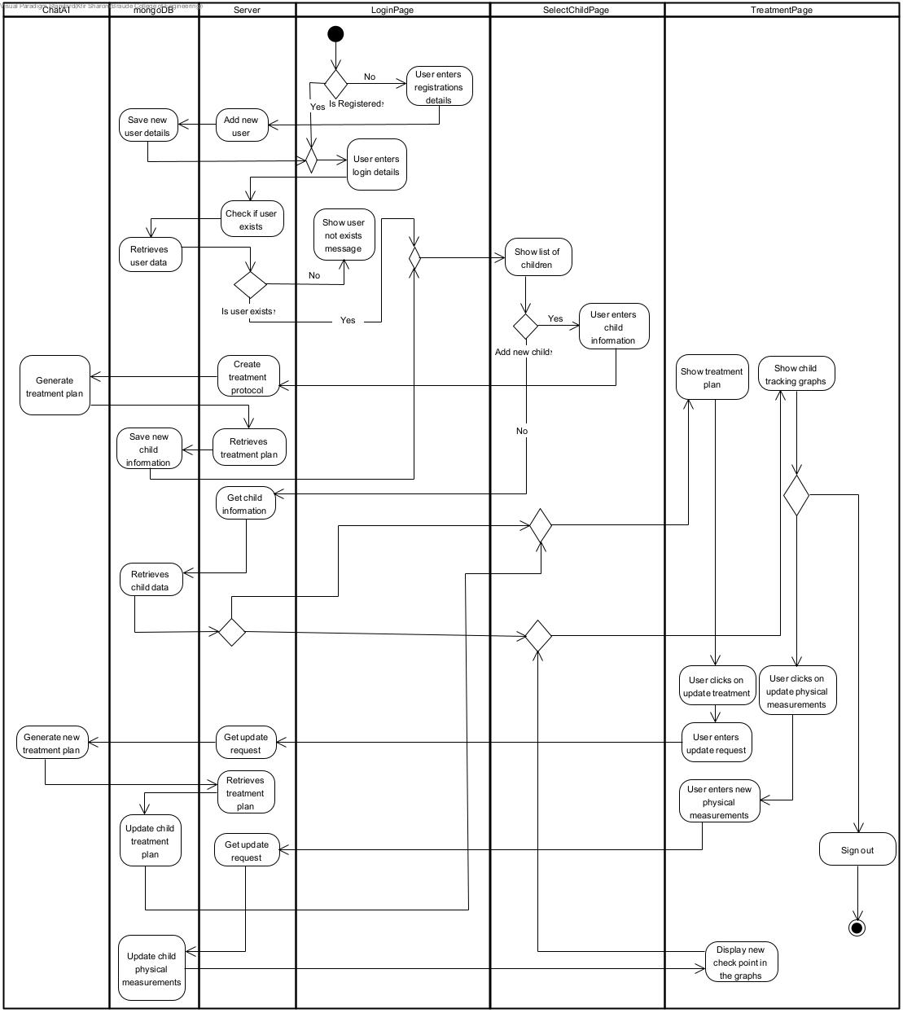
3.1 Activity diagram

3.2 Development Process
The development of the ThrivePath platform was grounded in the research and planning documented during Phase A of the project. In that initial phase, we identified the key medical, nutritional, and social aspects of Failure to Thrive (FTT) and translated them into a clear system specification. We reviewed existing tools such as FTTell, analyzed their limitations, and outlined the unique value our platform would provide delivering personalized treatment recommendations based on basic physical input (height, weight, age, and gender), without the need for diagnosis files or behavioral reports. This conceptual foundation guided every step of the development phase.
To build the platform, we followed a structured process. The first step involved translating clinical knowledge-such as WHO growth charts and recommended daily nutritional intake-into dynamic formulas that could be calculated programmatically. These calculations formed the core logic of our platform, allowing us to determine caloric needs, macronutrient distribution, and suggested lifestyle factors (sleep, hydration, supplements). This logic was implemented in Next.js API routes to serve requests and return data to the front-end.
The front-end of the application was built with React and styled using Tailwind CSS, ensuring a clean, responsive interface suitable for both desktop and mobile use. We designed the user flow to be intuitive: caregivers register, add children, input measurements, and receive an immediate, comprehensive plan. All user data is stored securely in a MongoDB database, enabling multi-profile management and historical data tracking.
One of the most significant technical challenges was integrating artificial intelligence through the OpenAI API. We aimed to use AI to generate rich, readable treatment plans based on the calculated data. This required us to design a prompt format that was both accurate and efficient. Initially, we struggled with long prompts that produced slow or inconsistent results. To solve this, we iterated multiple times on the prompt structure, eventually creating a Markdown-based format that could be parsed easily and rendered directly in the UI. This not only improved performance but also allowed for better control of tone and structure in the AI-generated content.
Another challenge was translating clinical data into usable code logic. Growth percentiles and nutritional targets vary widely depending on age and weight, and we needed to reflect that complexity while keeping the system maintainable. We implemented flexible data structures and functions that adjust outputs dynamically based on user input. Additionally, we had to ensure that all output-whether AI-generated or formula-based-was presented in a clear, approachable manner for users with no medical background. We focused on clean layout, structured headings, and actionable text to make the recommendations understandable and easy to apply.
In summary, ThrivePath was built using a modern and scalable technology stack: React + Tailwind CSS for the front-end, Next.js API Routes for the server-side logic, OpenAI API for generative recommendations, and MongoDB for data persistence. The system offers a practical, intelligent solution for FTT management, combining accurate calculations with the expressive capabilities of AI-all within an intuitive and user-friendly digital platform.

4. Use and maintenance

4.1 Package Diagram
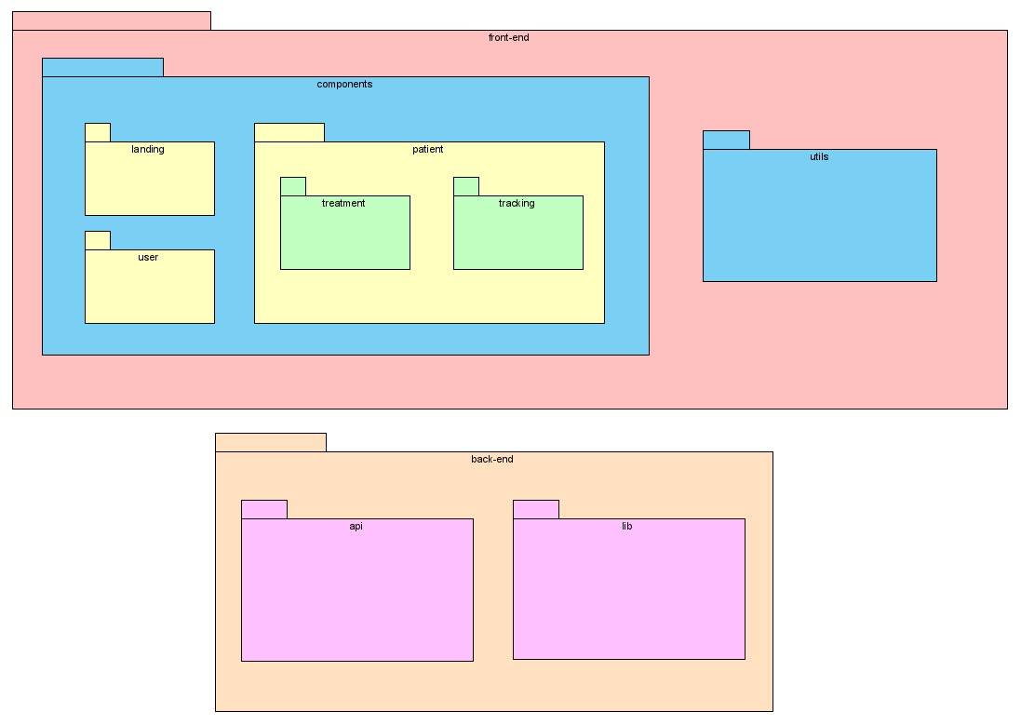

4.2 User Guide
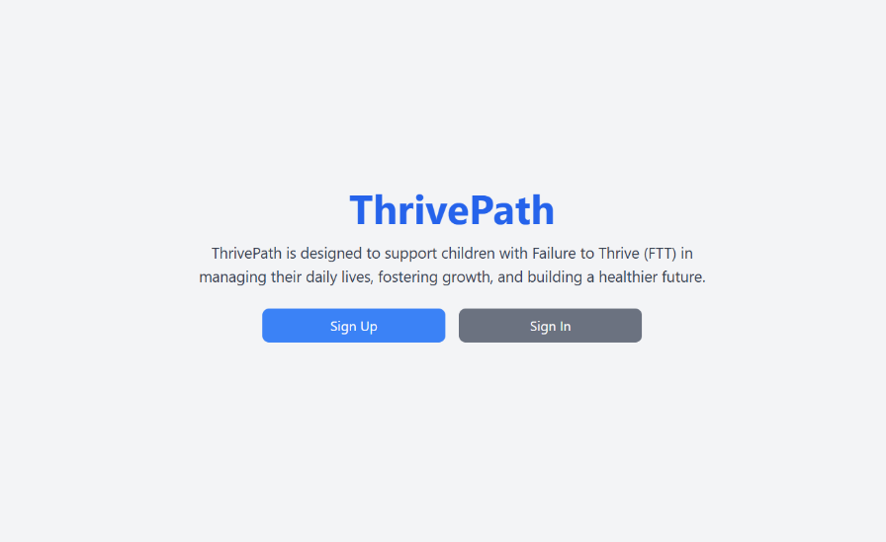
Home Page:

The home page displays the title ThrivePath and a short explanation about the platform’s purpose-helping children with Failure to Thrive manage their daily lives and health.
At the bottom of the page, there are two buttons: Sign Up for new user registration and Sign In for returning users to access their accounts.
Sign Up Page:
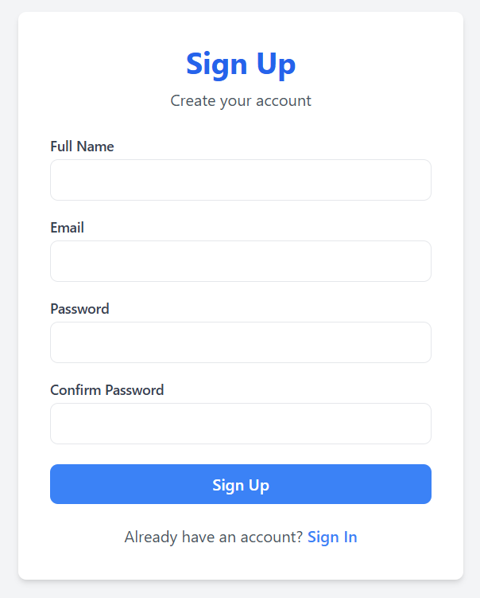

This is the Sign-Up page, where new users can create an account on the platform.
The form includes input fields for Full Name, Email, Password, and Confirm Password.
At the bottom, there's a Sign-Up button to submit the registration, and a Sign In link for users who already have an account.

Sign In Page:

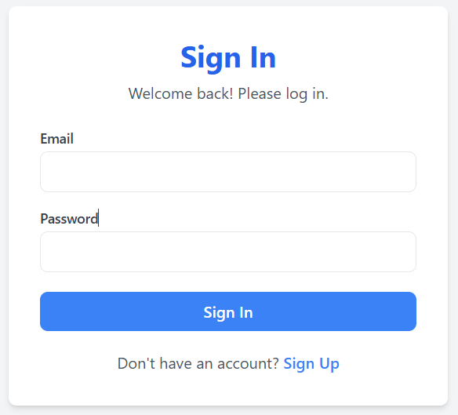

This is the Sign In page, where returning users can log into their ThrivePath account.
The form includes two fields: Email and Password, followed by a Sign In button to submit the login details.
At the bottom, there is a link to the Sign-Up page for users who don’t yet have an account.

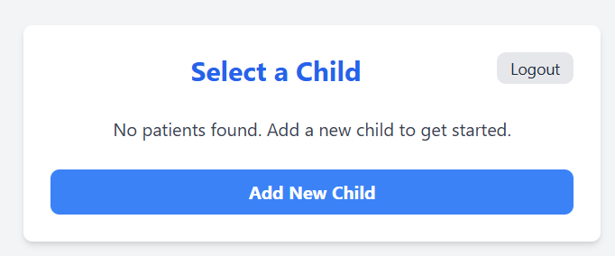
Add Child Page:

This page appears right after a successful login. The page includes a Logout button at the top right and a prominent Add New Child button to begin creating a new child profile.

Step 1:
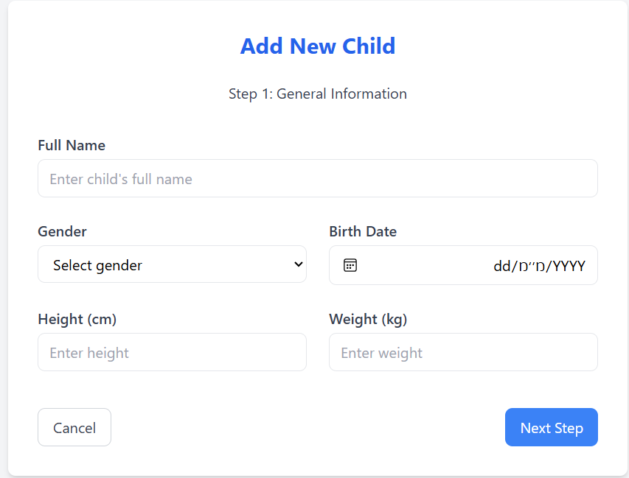

This page is Step 1 of the process to add a new child profile.
The user is prompted to enter general information, including the child’s Full Name, Gender, Birth Date, Height (cm), and Weight (kg).
At the bottom, there are two buttons: Cancel to exit the process and Next Step to continue to the next part of the registration.
Step 2:
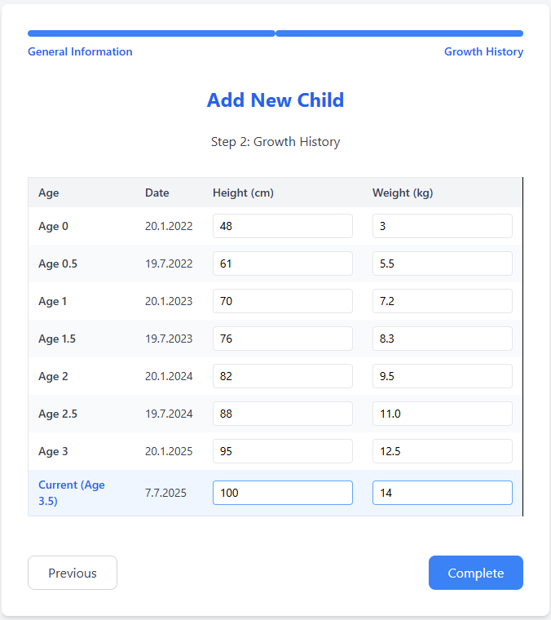

This is Step 2 of the child registration process, titled Growth History.
The user is asked to enter the child’s height and weight at various ages (e.g., age 0, 0.5, and 1 year), along with the corresponding dates.
Navigation options include a Previous button to go back to Step 1 and a Complete button to finish adding the child’s profile.
Select Child Page:
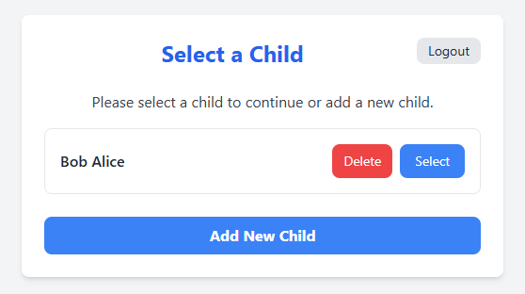

This is the child selection page, shown after at least one child profile has been added.
The user sees a list of existing child profiles-in this case, Bob Alice-with options to Select (blue button) or Delete (red button) the profile.
There is also a Logout button at the top right and an Add New Child button to register another child.
Treatment Plan:
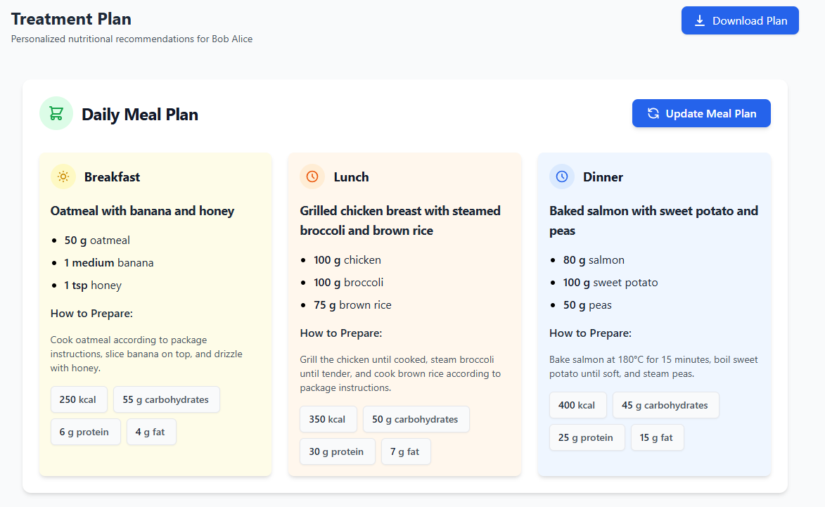

This page shows the Treatment Plan, personalized for the patient’s needs. It includes four parts: Meal Plan, Activity, Rest, and Hydration-all regularly updated to provide a full daily health routine. The page also includes buttons to download the entire plan as a PDF and to update the meal plan when needed.

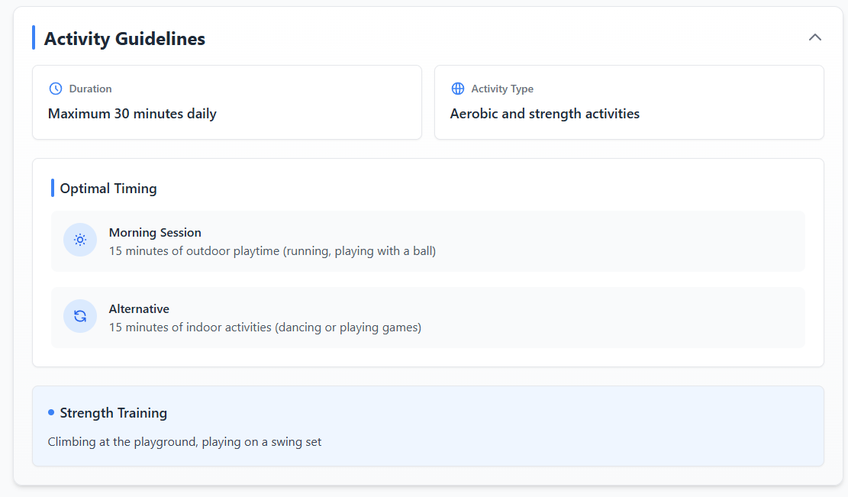

This section outlines customized daily activity recommendations, adjusted according to the patient’s condition and progress. It suggests aerobic and strength activities with flexible options for both outdoor and indoor sessions, as well as specific strength exercises. The guidelines are regularly updated to match the patient’s evolving physical capabilities and goals.

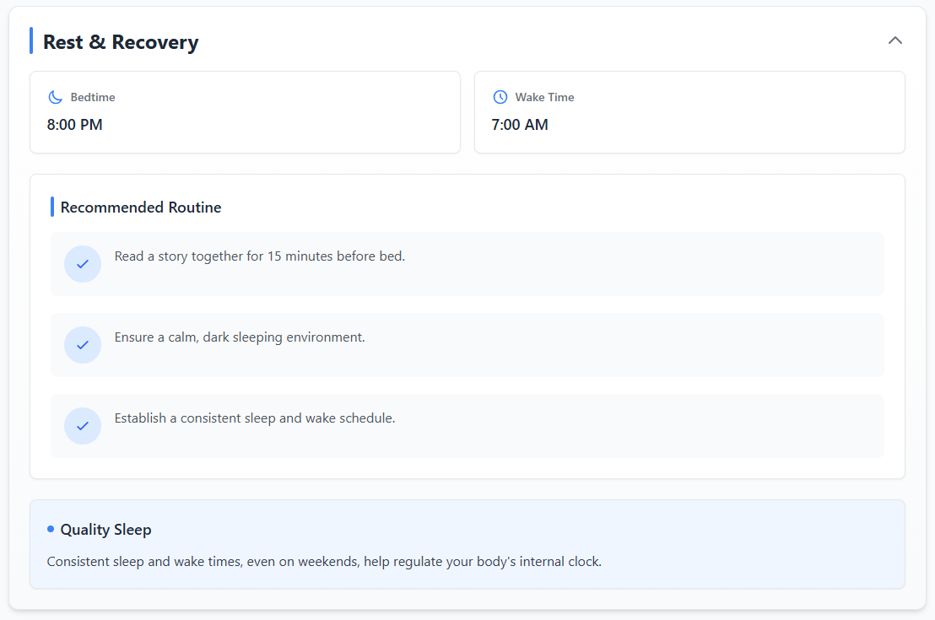

This section provides a personalized rest and recovery plan, designed to support the patient’s overall well-being. It includes a recommended bedtime and wake time, along with practical bedtime routines that promote quality sleep. These guidelines are adapted to the patient’s current needs and help maintain a consistent sleep schedule for better health.

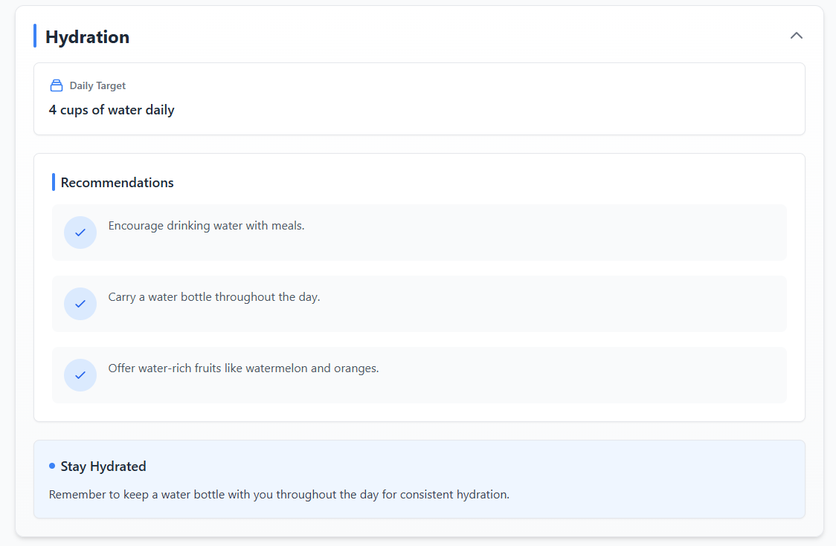

This section provides a personalized daily hydration goal, based on the patient's current needs. It recommends a specific water intake target along with practical tips such as drinking water with meals, carrying a water bottle, and consuming water-rich fruits. These suggestions are regularly adjusted to support consistent and healthy hydration habits.

Growth Tracking:
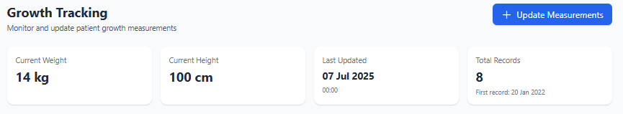

This section allows tracking and updating the patient’s growth measurements, including current weight, height, and measurement history. It shows the latest update date, total records, and provides a button to add new measurements easily.

Weight Chart
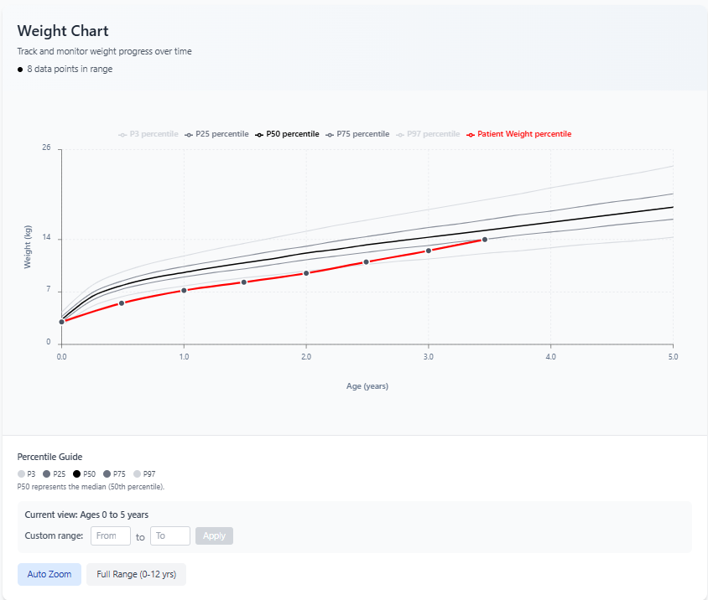

This section displays a Weight Chart to track the patient’s weight progress over time. It shows the patient's growth trend compared to standard percentiles, allowing easy monitoring of progress. Users can zoom in on specific age ranges or view the full growth history from birth to 12 years.

Height Chart
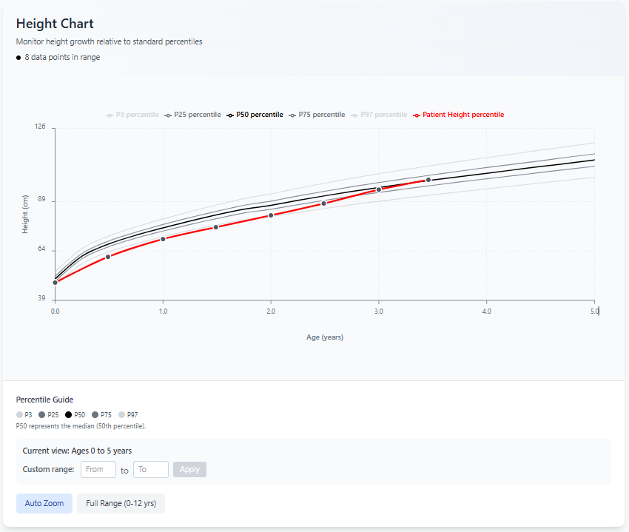

This section displays a Height Chart that tracks the patient’s height growth over time compared to standard percentiles. It visually shows how the patient's height progresses relative to typical growth curves. Users can easily adjust the age range to focus on specific time periods or view the entire growth history up to 12 years.
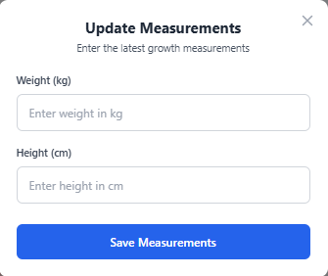
Update Measurements

This pop-up form allows users to update the patient’s latest growth measurements. It includes simple fields to enter the current weight and height, followed by a button to save the new measurements to the system.

4.3 Maintenance Guide
Frontend
Our frontend is built using React and Tailwind CSS, offering a dynamic and visually appealing user interface. React provides a robust framework for creating interactive components and managing application state, while Tailwind CSS delivers a flexible, utility-first approach to styling, ensuring a responsive and modern design.
App.jsx - Main Application Component
App.jsx file serves as the central routing hub for the ThrivePath platform. It defines how users navigate between different parts of the application - from public pages like the home or login, to protected user workflows such as selecting a patient, viewing treatment, and tracking progress.
Route Categories:
- Public pages: Home, SignUp, SignIn
- User flow after login: SelectPatient, AddPatientInfo, AddPatientHistory
- Patient-specific pages: TreatmentPage, TrackingPage (using dynamic :patientId)
Components
1. Landing Components
Contains files related to the home page and user authentication.
1.1 HomePage.jsx
The HomePage.jsx serves as the landing page for the ThrivePath application. The homepage provides a welcoming introduction to the app's mission and offers quick navigation options to either sign up or sign in. It's the first point of interaction for users visiting the app and lays the groundwork for user onboarding.
1.2 LoginPage.jsx
The LoginPage.jsx file defines the SignInPage component, which serves as the login screen for the ThrivePath application. Its purpose is to allow existing users to securely log in by submitting their email and password. Upon successful authentication, the user is redirected to the next part of the application.
State Declarations:
- formData: Holds the values entered in the email and password input fields. Ensures the form remains controlled and updates dynamically as the user types.
- error: Stores any error message that needs to be shown to the user if login fails or an unexpected issue occurs during the request.

Functions:
- handleChange: Updates the formData state when the user types into the email or password fields. Uses the name attribute of the input element to determine which field to update.
- handleSubmit: Triggered when the user submits the login form. Prevents default form submission, sends a POST request to /api/login, saves the token to localStorage on success, and redirects to /select-patient.
1.3 SignUpPage.jsx
The SignUpPage.jsx file defines the SignUpPage component, which provides a user registration form for the ThrivePath application. It allows new users to create an account by submitting their name, email, and password.
State Declarations:
- formData: Holds the user's input for the signup form: full name, email, password, and password confirmation.
- errorMessage: Stores any error messages displayed to the user if signup fails.
- successMessage: Shows a success message when signup is completed successfully.
Functions:
- handleChange: Updates the formData state whenever the user modifies any input fields.
- handleSubmit: Handles signup form submission, validates password matching, sends data to /api/signup, and displays appropriate feedback.
2. User Components
Contains files related to user workflows after login.
2.1 SelectPatient.jsx
This component allows a logged-in user to view, select, add, or delete patients (children) associated with their account. It fetches the patient list from the backend and manages user interactions.
State Declarations:
- patients: Array holding patient objects fetched from the server.
- error: String storing error messages encountered during operations.
- isLoading: Boolean indicating if patient data is currently being loaded.
- showDeleteConfirm: Boolean controlling the visibility of the delete confirmation modal.
- patientToDelete: Stores the patient object intended for deletion.
Functions:
- useEffect hook: Fetches patient list on component mount, validates token, and handles authentication.
- handleSelect(patientId): Navigates to the treatment page for the selected patient.
- handleAddNewChild(): Navigates to the add new patient page.
- handleLogout(): Clears the saved token and redirects to signin.
- handleDeleteClick(patient): Sets the selected patient for deletion and shows confirmation modal.
- handleConfirmDelete(): Sends DELETE request to remove patient from backend.
- handleCancelDelete(): Hides confirmation modal and clears selected patient.
2.2 AddPatientInfo.jsx
This component collects general information about a new child patient including name, gender, birthdate, height, and weight, with validation and navigation to the next step.
State Declarations:
- formData: Object holding form inputs: name, gender, birthdate, height, and weight.
- errors: Object holding validation error messages for each field.
- hasSubmitted: Boolean indicating if the form has been submitted at least once.
Helper Functions:
- getMaxDate(): Returns today's date as YYYY-MM-DD format for maximum birthdate validation.
- getMinDate(): Returns the date 12 years ago for minimum birthdate validation.
Functions:
- useEffect hook: Runs validation after first submission whenever form data changes.
- validate(): Validates all input fields and returns error object with specific validation rules.
- handleChange(event): Updates formData state when any input changes.
- handleSubmit(event): Prevents default submission, validates form, and navigates to next step with data.
2.3 AddPatientHistory.jsx
This component allows users to enter a child's historical growth data (height and weight) from birth to present, in 6-month intervals.
State Declarations:
- growthHistory: Array of age-based entries with date, height, and weight.
- errors: Object for field-specific validation messages.
- error: General error message.
- isLoading: Boolean for save progress state.
Helper Functions:
- generateGrowthEntries: Creates entries from birthdate to today every 6 months.
- calculateAgeInYears: Computes decimal age from birthdate.
Functions:
- handleGrowthChange(index, field, value): Updates a field in a specific entry.
- validateForm(): Validates height (30-200 cm) and weight (2-150 kg) ranges.
- handleSubmit(event): Validates form, generates protocol/treatment, and submits to /api/add-new-patient.
3. Patient Components
Contains files related to patient-specific functionality.
3.1 Dashboard.jsx
The Dashboard component displays a patient's treatment overview by rendering four key subcomponents: MealPlan, PhysicalActivity, SleepSchedule, and Hydration.
Props:
- treatment: Object containing all treatment sections.
- patient: Patient data passed for personalized display.
- protocol: Protocol data available for components.
Behavior: Shows loading message if treatment is not loaded, otherwise renders the four treatment components with relevant data.
3.2 Treatment Components
3.2.1 TreatmentPage.jsx
This page fetches and displays a patient's treatment plan using the Dashboard component. Includes navigation, PDF export, and mobile menu functionality.
State Declarations:
- patient, treatment: Loaded from /api/get-patient-treatment.
- isLoading, error: Handle loading and error states.
- menuOpen: Controls mobile menu visibility.
Functions:
- handleDownloadPlan(): Captures dashboard as PDF using html2canvas and jsPDF.
- handleGoBack(): Navigates to select-patient page.
- handleLogout(): Clears token and redirects to signin.
3.2.2 MealPlan.jsx
Displays a patient's daily meal plan including breakfast, lunch, and dinner sections with options, portions, nutrition, and preparation. Includes functionality to refresh the plan via OpenAI.
State Declarations:
- patientData: Patient info used for protocol.
- currentMealPlan: Holds the meal plan to display.
- loading, isMealsVisible: Control loading state and visibility.
Functions:
- handleRefresh(): Sends prompt to OpenAI API to regenerate meal plan based on protocol.
- parseNutrition(), renderNutrition(): Handle nutrition breakdown display.
- renderPortionItem(): Parses and formats portion lines.
3.2.3 PhysicalActivity.jsx
Displays physical activity guidelines including type, duration, timing suggestions, and muscle-strengthening tips. Sections can be toggled open/closed.
State Declarations:
- isExpanded: Controls visibility of the activity content.
Props:
- activity: Object with duration, type, timingSuggestions, and muscleStrengtheningActivities.
3.2.4 Hydration.jsx
Displays daily water intake targets and hydration tips for the patient. Content can be expanded or collapsed.
State Declarations:
- isExpanded: Toggles hydration section visibility.
Props:
- hydration: Includes totalWater (target) and tips (list of suggestions).
3.2.5 SleepSchedule.jsx
Displays the patient's bedtime and wake time, along with routine tips for better sleep. The content is collapsible.
State Declarations:
- isExpanded: Controls whether the sleep section is shown.
Props:
- sleep: Contains bedtime, wakeTime, and routineTips.
3.3 Tracking Components
3.3.1 TrackingPage.jsx
Displays patient growth history with charts, stats, and an update form. Fetches and visualizes historical height and weight data.
State Declarations:
- historyData: Array of formatted growth entries.
- showForm, formWeight, formHeight: Control for update modal and input.
- isLoading, menuOpen, activeTab: UI and tab state.
Functions:
- handleSubmitForm(): Submits new weight/height, updates treatment and protocol, appends new entry, and sorts data by age.
3.3.2 HeaderSection.jsx
Reusable header for the tracking page with navigation and logout options. Supports responsive mobile menu.
Props:
- menuOpen, setMenuOpen: Control mobile menu toggle.
- navigate, patientId: Used for routing between views.
3.3.3 StatsSummary.jsx
Displays key stats about the patient's latest growth record and provides a button to update measurements.

Props:
- latestEntry: Most recent history entry.
- historyData: Full list of patient records.
- onUpdateClick: Opens update modal.
- activeTab, setActiveTab: Control chart filter (All/Weight/Height).
3.3.4 GrowthCharts.jsx
Displays interactive line charts for tracking patient weight and height over time against standardized percentiles.
Features:
- Renders one or two charts (ChartBlock) based on activeTab
- Patient data line with tooltips and percentile context
- Percentile curves (P3–P97)
- Interactive zoom: auto, full range, or custom age range
- Tooltip explains age, measurement, date, and percentile range
Props:
- historyData: Array of measurement records.
- activeTab: 'all', 'weight', or 'height'.
- birthDate: Patient's birthdate for date corrections.
3.3.5 UpdateMeasurementModal.jsx
Modal form for adding a new weight and height entry to the patient's history.
Props:
- onClose: Closes the modal.
- onSubmit: Handles form submission.
- formWeight/setFormWeight: Controlled weight input.
- formHeight/setFormHeight: Controlled height input.
- isLoading: Disables form when true.

3.3.6 DeleteConfirmationModal.jsx
Modal confirmation dialog for deleting a selected growth checkpoint from the patient's history.

Props:
- isOpen: Controls visibility of the modal.
- onClose: Closes the modal.
- onConfirm: Handles deletion confirmation
- dataPoint: Object containing the selected record (date, weight, height).
- isLoading: Disables buttons and shows spinner while deleting
Backend
Our backend is built using Next.js API routes with MongoDB as the database, providing a robust server-side foundation for the ThrivePath platform. The API architecture includes multiple endpoints for various functionalities, with each route implementing proper error handling, CORS configuration, and authentication mechanisms where required.
API Endpoints
1. signup.js - User Registration Endpoint
Handles new user registration for the ThrivePath application.
Purpose: Allow new users to create accounts by providing their name, email, and password.
HTTP Method: POST
Endpoint: /api/signup
Request Body:
- name: User's full name
- email: User's email address (converted to lowercase)
- password: User's password
Key Functions:
- Email Validation: Checks if the provided email already exists in the database using case-insensitive search. Returns 409 status if email already exists.
- User Creation: If email is unique, inserts a new user document into the MongoDB users collection. Returns the newly created user's ID upon success.
- Error Handling: Comprehensive error handling for database operations with appropriate HTTP status codes (409 for conflicts, 500 for server errors, 405 for unsupported methods).

2. login.js - User Authentication Endpoint
Manages user authentication by validating credentials and generating JWT tokens for authenticated sessions.
Purpose: Authenticate existing users and provide secure access tokens.
HTTP Method: POST
Endpoint: /api/login
Request Body:
- email: User's email address
- password: User's password
Key Functions:
- Credential Validation: Validates that both email and password are provided, searches database for matching user, and compares passwords.
- JWT Token Generation: Upon successful authentication, generates a JWT token containing the user's ID using the JWT_SECRET environment variable.
- Security Measures: Protection against invalid credentials with 401 status for authentication failures and comprehensive error handling.
3. get-user-patients.js - Patient Retrieval Endpoint
Retrieves all patients associated with a specific authenticated user.
Purpose: Fetch all patients belonging to the authenticated user for display in the patient selection interface.
HTTP Method: GET
Endpoint: /api/get-user-patients
Authentication: Requires valid JWT token in Authorization header
Key Functions:
- Token Validation: Extracts and validates JWT token from Authorization header, decodes token to extract user ID.
- Patient Retrieval: Queries MongoDB patients collection to find all documents where userId matches the authenticated user's ID. Returns both patient array and total count.
- Error Handling: Specific error handling for missing authorization tokens, invalid JWT tokens, and database operation failures.
4. add-new-patient.js - Patient Creation Endpoint
Handles the creation of new patient records associated with authenticated users.
Purpose: Create new patient records with comprehensive patient information including personal details, growth history, protocols, and treatment plans.
HTTP Method: POST
Endpoint: /api/add-new-patient
Authentication: Requires valid JWT token in Authorization header
Request Body: Complete patient data object including name, gender, birthdate, and additional patient information.
Key Functions:
- Data Validation: Validates that essential patient information is provided, specifically checking for name, gender, and birthdate. Returns 400 status if required fields are missing.
- Patient Record Creation: Creates a new patient document by combining provided patient data with the authenticated user's ID.
- Database Integration: Inserts the new patient record into the MongoDB patients collection and returns the newly created patient's ID.
5. delete-patient.js - Patient Deletion Endpoint
Manages the secure deletion of patient records, ensuring only authorized users can delete their own patients.
Purpose: Remove patient records from the database with proper authorization checks.
HTTP Method: DELETE
Endpoint: /api/delete-patient
Authentication: Requires valid JWT token in Authorization header
Request Body:
- patientId: MongoDB ObjectId of the patient to delete
Key Functions:
- Patient ID Validation: Validates that a patient ID is provided and that it's a valid MongoDB ObjectId format.
- Ownership Verification: Ensures that the patient belongs to the authenticated user by including both patient ID and user ID in the deletion query.
- Secure Deletion: Performs targeted deletion using MongoDB's deleteOne operation with compound criteria (_id and userId).
6. get-patient-treatment.js - Treatment Data Retrieval Endpoint
Retrieves comprehensive patient information including treatment plans, protocols, and historical data.
Purpose: Fetch detailed patient information for display in treatment views and patient management interfaces.
HTTP Method: GET
Endpoint: /api/get-patient-treatment
Authentication: Requires valid JWT token in Authorization header
Query Parameters:
- patientId: MongoDB ObjectId of the patient to retrieve
Key Functions:
- Patient Lookup: Queries database for patient record matching both provided patient ID and authenticated user's ID.
- Selective Data Return: Returns specific fields (name, _id, birthdate, treatment, protocol, history) to optimize response size.
- Treatment Data Structure: Response includes structured treatment data for direct consumption by frontend components.
7. update-patient-history.js - Patient Data Update Endpoint
Manages updates to patient records, specifically adding new historical entries and updating treatment protocols.
Purpose: Add new growth measurements to patient history while simultaneously updating treatment protocols and plans.
HTTP Method: PUT
Endpoint: /api/update-patient-history
Authentication: Requires valid JWT token in Authorization header
Request Body:
- patientId: Patient's MongoDB ObjectId
- newEntry: Object containing weight and height measurements
- protocol: Updated protocol information
- treatment: Updated treatment plan
Key Functions:
- Comprehensive Validation: Thorough validation of all required fields, ensuring proper formatting of patient ID, entry data, protocol, and treatment information.
- Atomic Updates: Uses MongoDB's updateOne operation with both $push and $set operators to atomically add historical data while updating protocol and treatment.
- Historical Tracking: New entries are automatically timestamped if not provided, maintaining chronological records.

8. update-treatment.js - Treatment Plan Update Endpoint
Manages updates to patient treatment plans, allowing modifications to meal plans, physical activity schedules, sleep routines, and hydration guidelines.
Purpose: Update existing patient treatment plans with new or modified treatment data while maintaining proper authorization and data integrity.
HTTP Method: PUT
Endpoint: /api/update-treatment
Authentication: Requires valid JWT token in Authorization header
Request Body:
- patientId: Patient's MongoDB ObjectId
- updatedTreatment: Complete treatment object with updated plans
Key Functions:
- Treatment Validation: Validates that both patient ID and updated treatment data are provided.
- Patient Verification: Verifies that the specified patient exists and belongs to the authenticated user.
- Treatment Update: Uses MongoDB's updateOne operation with $set operator to replace the entire treatment object atomically.
- Update Confirmation: Checks modifiedCount from database operation to confirm changes were made.
9. openai.js - OpenAI API Integration Endpoint
Provides integration with OpenAI's GPT models to generate dynamic content for treatment plans and patient care recommendations.
Purpose: Process AI-powered requests for generating or updating treatment content, particularly meal plans and care recommendations.
HTTP Method: POST
Endpoint: /api/openai
Authentication: Requires valid JWT token in Authorization header
Request Body:
- messages: Array of message objects formatted for OpenAI's chat completion API
Key Functions:
- OpenAI Configuration: Initializes OpenAI client using OPENAI_SECRET environment variable and configures "gpt-4o-mini" model.
- Message Processing: Validates that request contains properly formatted messages array following OpenAI's expected format.
- AI Response Handling: Extracts AI-generated content from response and returns it for integration into treatment plans.
- Error Management: Specific error handling for OpenAI API failures, authentication issues, and malformed requests.
Utility Libraries
The backend includes several utility libraries in the /lib folder that provide shared functionality across all API routes, ensuring consistency and maintainability.
Database Connection Management
mongodb.js - Database Connection Utility
Manages MongoDB connections with environment-specific optimizations to ensure efficient database operations across the application.
Purpose: Provide a centralized, optimized database connection function that handles connection pooling and error management.
CORS Configuration
cors.js - Cross-Origin Resource Sharing Setup
Configures CORS policies to enable secure communication between the frontend and backend applications.
Purpose: Manage cross-origin requests by defining allowed methods, origins, and headers for API security.
Application Settings
settings.js - Application Configuration
Contains centralized configuration values used throughout the application.
Purpose: Provide a single source of truth for application-wide configuration settings.

5 Testing

5.1 User Authentication Testing:
1. Homepage Access:
Users begin on the homepage, where they can choose between signing up or logging in. We verified that both navigation buttons correctly route users to the Sign Up and Sign In pages, ensuring the routing works under all conditions.
2. User Registration Process:
On the Sign Up page, users are required to enter their full name, email, password, and password confirmation.
We tested:
- Field validations, ensuring all fields are mandatory.
- Password confirmation checks, verifying that mismatched passwords trigger the correct error message.
- Submission of the form triggers an API call (/api/signup) with the correct payload.
- System behavior on successful registration: clearing the form, displaying a success message, and allowing navigation to the login page.
- Error handling with incorrect or duplicate data inputs, ensuring the correct error messages appear.
3. User Login Process:
On the Sign In page, users input their email and password.
We tested:
- Field validations for required fields.
- Submission of the form triggers an API call (/api/login) with the appropriate payload.
- On successful login, the system stores the returned token in localStorage and navigates the user to the patient selection page.
- Handling of failed login attempts with incorrect credentials, displaying clear error messages.
- System resilience by testing unexpected inputs and server errors.
4. Final Outcome:
Testing confirmed that the authentication flow is functional, with clear user feedback at each step. The process ensures both security and usability, allowing smooth navigation between registration and login.
Additionally, API responses are correctly handled, and user tokens are securely stored for session management.

5.2 Patient Management Process Testing:
1. Patient Selection Page:
After login, users are directed to the Patient Selection page, where they can view, select, add, or delete patient profiles.
We tested:
- Data fetching: Verified that the system correctly retrieves the user’s patients using the stored token.
- Navigation: Ensured selecting a patient redirects to the treatment page, while clicking “Add New Child” opens the patient registration form.
- Error handling: Tested failed API calls and confirmed proper error messages are displayed.
- Patient Deletion: Verified deletion process, including confirmation modal, token-based authorization, and refreshing the patient list after deletion.
2. Add New Patient - Step 1 (General Information):
Users must fill in the child’s basic info: full name, gender, birth date, height, and weight.
We tested:
- Field validations: Ensured validations for all fields, including allowed characters, valid dates (birth date must not exceed age 12 or be in the future), and realistic height/weight ranges.
- Error messages: Confirmed clear, user-friendly error prompts on invalid inputs.
- Navigation: Verified that submitting valid data correctly moves to the next step with the data passed to the next page.
3. Add New Patient - Step 2 (Growth History):
Users input the child’s historical growth data in 6-month intervals.
We tested:
- Auto-generation of intervals: Verified correct creation of growth records from birth to the current date.
- Editing growth records: Ensured that users can input height and weight for each interval.
- Field validations: Confirmed that all entered data adheres to acceptable ranges.
- Protocol & Treatment Generation: Validated the generation of the treatment plan via the helper function, ensuring accurate results based on the provided birth date, gender, and weight.
- Saving patient data: Verified that submitting the form successfully sends the complete patient data to the backend and redirects back to the patient selection page.
4. Final Outcome:
Testing confirmed that the patient management process is stable, with proper error handling, accurate validations, and smooth navigation across all steps.
The flow ensures that pediatricians can easily manage patient records while maintaining data accuracy and security.

5.3 Treatment Plan Dashboard Testing:
1. Treatment Page Loading:
After selecting a patient, users are directed to the Treatment Page, where the system fetches the latest treatment plan.
We tested:
- Data fetching: Verified correct API calls for retrieving patient and treatment data using the stored token.
- Error handling: Ensured appropriate error messages are displayed if data fails to load.
- Navigation: Confirmed correct routing to the Treatment and Tracking pages, as well as logout functionality.
- PDF Export: Tested the feature for downloading the entire treatment plan as a PDF, ensuring it captures the dashboard accurately, including hiding UI elements during export.
2. Dashboard Sections Testing:
The Dashboard presents the full treatment plan, split into four collapsible sections:
- Meal Plan:
Displays detailed meal plans (breakfast, lunch, dinner, snacks) with nutrition info and preparation steps.
Tested the ability to regenerate a new meal plan via AI, ensuring it replaces the old one and saves correctly to the backend.
- Physical Activity:
Shows daily exercise recommendations, including activity type, duration, optimal timing, and strength activities.
Verified content accuracy and user-friendly display.
- Sleep Schedule:
Displays suggested bedtime, wake time, and daily sleep routine tips.
Confirmed readability and collapsibility.
- Hydration:
Presents daily water intake goals and hydration tips.
Checked clarity of recommendations and toggling behavior.
Each section was tested for:
- Expand/collapse functionality.
- Correct display of personalized content.
- Mobile responsiveness and usability.
- Seamless integration between sections.
3. Final Outcome:
Testing confirmed that the Dashboard provides a complete, clear, and functional overview of the patient’s treatment plan.
All functionalities - including AI-driven updates, PDF export, and dynamic section toggling - worked as intended.
The user interface remains responsive and easy to navigate across devices.

5.4 Patient Growth Tracking Process Testing:
1. Tracking Page Loading:
After selecting the Tracking tab, users are directed to the Tracking Page, which shows patient growth history.
We tested:
- Correct data fetching from the patient’s history, with accurate age calculations based on birthdate and measurement dates.
- Sorting of measurements by age to ensure consistent chart rendering.
- Navigation between tabs (All, Weight, Height) for focused analysis.
2. Growth Stats and Update Measurements:
The Stats Summary section displays key data points:
- Current weight and height.
- Last update date and time.
- Total number of records.
We tested:
- Accurate display of the latest measurements.
- Opening the Update Measurement Modal to add new records.
- Validations for numeric inputs and realistic values.
- Successful submission updates both the growth history and backend, with immediate updates to charts and stats.
3. Growth Charts Functionality:
The Growth Charts visualize weight and height trends against standard percentiles.
We tested:
- Dynamic chart rendering with zoom controls (auto, full range, custom age range).
- Interactive tooltips showing detailed stats, percentiles, and measurement dates.
- Double-click functionality to trigger deletion of specific checkpoints.
- Deletion process including confirmation modals, API calls, and automatic updates to charts and records after deletion.
4. User Interface & Navigation:
We tested:
- Smooth navigation between Treatment and Tracking pages.
- Mobile responsiveness and correct display of header, stats, and charts.
- Logout and back-to-patient functionality.
5. Final Outcome:
Testing confirmed that the Growth Tracking flow is stable, intuitive, and fully functional.
Users can easily:
- Track patient progress.
- Add or delete growth records.
- Analyze trends against medical standards.
All operations correctly sync with the backend and provide clear visual feedback, ensuring reliable use in pediatric care.

6. Results and Conclusions

6.1 Project Objectives and Achievements:
The main objective of our project was to create an innovative and practical digital platform that provides personalized treatment recommendations along with continuous growth monitoring for children diagnosed with Failure to Thrive (FTT). From the very beginning, we aimed to design a system that would not only assist in managing the condition but also offer real, long-term value for both caregivers and healthcare professionals.
We believe this objective has been fully achieved. The platform we developed generates detailed and individualized treatment plans, based on simple, accessible data such as the child’s age, gender, weight, and height. These plans deliver clear and practical recommendations in four essential areas-nutrition, physical activity, sleep, and hydration-presented in a way that is easy to understand and implement, even for caregivers with no medical background.
A central strength of the system lies in its ability to provide a personalized care pathway for each child. Every treatment plan is tailored to the child’s specific needs and can be updated as the child’s condition changes over time. This makes the platform much more than a static tool-it serves as a dynamic and supportive system that adapts throughout the child’s growth.
One of the most impactful achievements of this project is the development of the Growth Monitoring feature. This functionality transforms the platform from a simple recommendation tool into a comprehensive long-term health management solution.
Through this feature, caregivers can regularly record and update the child’s growth data. The system automatically processes this information and presents it through clear, easy-to-read graphs that compare the child’s progress to standardized pediatric growth charts. This enables caregivers to easily recognize trends, identify potential concerns, and make informed decisions about the child’s care.
Furthermore, every time new measurements are added, the system updates the treatment recommendations accordingly. This ensures that caregivers always receive accurate and up-to-date guidance, aligned with the child’s current condition. The combination of continuous tracking with automatic plan updates provides caregivers with a powerful, effective tool to manage growth challenges over time.
This strong connection between growth monitoring and personalized recommendations is what makes the platform particularly effective. It not only provides recommendations but also empowers caregivers to actively monitor whether the treatment is working and to adjust it as needed.
In summary, the project successfully resulted in a complete, accessible, and effective platform for managing FTT in children. Its simplicity enables caregivers to easily apply the recommendations in their daily routines, while its adaptability ensures that treatment plans evolve as the child grows.
While the system also includes basic privacy and data protection measures, the main value of the platform lies in its ability to guide caregivers through every stage of FTT management-from initial recommendations to long-term monitoring and continuous care adjustments.
This project clearly demonstrates the potential of digital tools to provide meaningful, ongoing support to both families and healthcare professionals facing complex growth-related challenges.

6.2 Considerations in Our Decision-Making Process
Throughout the development of this project, our decision-making process was shaped by clear priorities and careful evaluation of every option. From the initial planning stages, we were fully aware that our main challenge was to balance functionality, accuracy, and usability, while working within the time and resources available to us.
One of our first and most important decisions was to focus the platform specifically on personalized treatment recommendations and growth tracking, rather than attempting to integrate diagnostic capabilities or complex medical assessments. We understood that many existing tools already addressed diagnostics, but there was a clear need for a solution that could guide caregivers with practical, daily treatment plans. This focus allowed us to build a system that is both accessible and meaningful for families managing Failure to Thrive (FTT).
Another key consideration was ensuring that the system remained simple and intuitive. We knew that many users-especially caregivers-may not have medical or technological expertise. This led us to prioritize a clean, straightforward design and to avoid features that might complicate the user experience. Every functionality we added was tested to ensure it remained easy to navigate and genuinely helpful.
When choosing technologies for development, we deliberately selected tools that would allow us to build a responsive, scalable, and maintainable system. React was chosen for its flexibility in building user interfaces, while Next.js API routes and MongoDB allowed us to efficiently manage data and backend processes. These decisions were guided not only by technical suitability but also by our team’s familiarity with these technologies, ensuring we could complete the project effectively within the required timeframe.
We also placed great importance on making the platform adaptable over time. By designing the treatment generation logic to rely on adjustable parameters-such as age, weight, and growth history-we ensured that the system could evolve with each child’s needs. This adaptability was a central principle in every major design choice we made.
Finally, we consistently reviewed every major decision in terms of long-term impact. We prioritized features that would provide real value to users beyond the initial launch, focusing on sustainable functionality like growth monitoring and automatic treatment updates. When we faced more complex decisions or competing priorities, we sought guidance from our project supervisor to ensure that our choices remained aligned with both the project’s goals and realistic timelines.
Throughout the process, we remained focused on creating a platform that not only works but also makes a meaningful difference in managing FTT. Every decision-from feature selection to system design-was guided by the desire to deliver a reliable, practical, and supportive tool for caregivers and healthcare professionals alike.

